Conservative estimates put U.S. direct subsidies to the fossil fuel industry at roughly $20 billion per year; with 20 percent currently allocated to coal and 80 percent to natural gas and crude oil. European Union subsidies are estimated to total 55 billion euros annually.
(Thanks to Nadia Colburn for this research.)

Here's an article about what we could do we 20 billion:
https://www.dailykos.com/stories/2016/8/14/1559053/-Ten-things-we-could-buy-with-25-billion-other-than-a-wall

Profits of big oil:
https://www.oilandgasiq.com/strategy-management-and-information/articles/oil-and-gas-companies

What oil executives make:
And the compensation of all oil and gas executives in our sample, all told, totals almost $1 billion per year, making the money at stake substantial. With median pay for U.S. CEOs nearly $12 million per year, executive compensation has become more complicated and important to understand than ever. Sep 4, 2018

This is a good story about what oil companies do with their money--it's a bit dated, but good numbers: https://thinkprogress.org/what-five-oil-companies-did-with-their-375-million-in-daily-profits-920ad33d1641/

- These five oil companies received $6.6 million in federal tax breaks every day.
- In 2011, the three largest domestic public oil companies spent $100 million of their profits each day, or over 50 percent, buying back their own stock to enrich their board, senior managers, and largest share holders.
- The entire oil and gas industry spent on average $400,000 each day lobbying senators and representatives to weaken public health safeguards and keep big oil tax breaks, totaling nearly $150 million.
- Each CEO of the Big Five companies received an average of $60,110 in compensation per day last year. On average, their pay jumped 55 percent in 2011. Exxon CEO Rex Tillerson’s compensation came close to $100,000 per day last year.
- Despite ranking as some of the most successful companies in the world, big oil and gas companies continue to receive $4 billion in tax breaks each year.
- The oil and gas industry has already given over $30.5 million in federal campaign contributions this year, with a whopping 88 percent going to Republicans.
- Big Oil has spent an additional $70 million on lobbying Congress this year, with the top spenders being Exxon, Shell, Chevron, Koch Industries and BP.
- Fueled by Koch Industries and other Big Oil interests, the industry is spending hundreds of millions to fund false ads in this year’s elections. According to the Annenberg Public Policy Center, 85 percent of the dollars have funded false ad, during a season where most advertising have focused on energy.
- Pro-Romney outside interest groups spent $24.6 million on energy ads through June 24, according to Kantar Media CMAG data. This is more than ten-times the amount spent by pro-Obama groups, which spent $2.3 million on energy spots.
- American Energy Alliance, Americans for Prosperity, American Future Fund, and Crossroads GPS — the top outside pro-oil and pro-Romney interest group spenders — have spent a total $24.9 million on deceptive ads, many of them energy-related, according to the Annenberg Public Policy Center.
- Oil companies pay only a 21% tax rate...at most, but most companies pay lower...look at this story: Chevron not only paid NO taxes on its 4.5 billion of profits, it got a refund!
https://www.motherjones.com/politics/2020/01/chevron-made-4-5-billion-in-2018-so-why-did-the-irs-give-them-a-refund/

Recent Data:

- https://www.bloomberg.com/news/articles/2020-05-15/-stealth-bailout-shovels-millions-of-dollars-to-oil-companies

- https://www.theguardian.com/environment/2020/may/12/us-fossil-fuel-companies-coronavirus-bailout-oil-coal-fracking-giants-bond-scheme

- https://raskin.house.gov/media/press-releases/rewind-act-prohibits-bailout-fossil-fuel-industry-cares-act-funds-during-public#:~:text=%E2%80%9CThe%20CARES%20Act%20passed%20to,us%20closer%20to%20climate%20catastrophe.%E2%80%9D&text=%E2%80%9CWe%20already%20subsidize%20fossil%20fuel,Omar.

- https://www.jacobinmag.com/2020/06/cares-act-coronavirus-fossil-fuel
“fossil fuel companies are likely to account for $19 billion of these purchases”

- https://www.eesi.org/papers/view/fact-sheet-fossil-fuel-subsidies-a-closer-look-at-tax-breaks-and-societal-costs#:~:text=Conservative%20estimates%20put%20U.S.%20direct,total%2055%20billion%20euros%20annually.
Conservative estimates put U.S. direct subsidies to the fossil fuel industry at roughly $20 billion per year; with 20 percent currently allocated to coal and 80 percent to natural gas and crude oil.
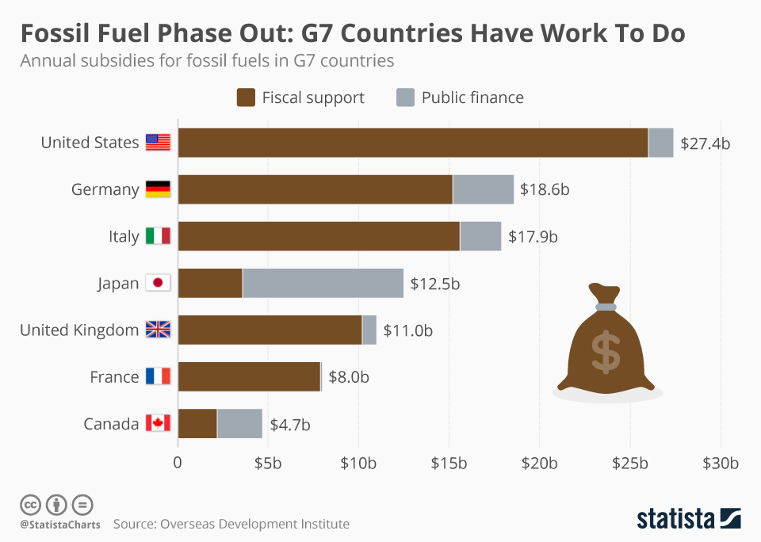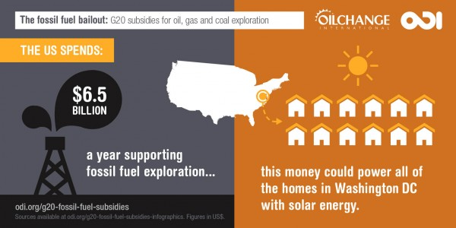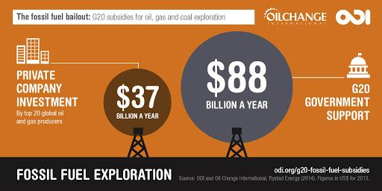

Subsidies
20 percent of subsidies go to coal corps.
80 percent go to oil and natural gas corps.
https://thinkprogress.org/what-five-oil-companies-did-with-their-375-million-in-daily-profits-920ad33d1641/

Tax Breaks
Oil, coal, and nat gas receives tens of millions in tax breaks every year
https://thinkprogress.org/what-five-oil-companies-did-with-their-375-million-in-daily-profits-920ad33d1641/

Oil companies pay only a 21% tax rate at most. In 2012, Chevron received a refund on their 4.5 billion in profit. (is this still valid?)

Salary
Oil and Gas Execs make upwards of one billion a year
https://thinkprogress.org/what-five-oil-companies-did-with-their-375-million-in-daily-profits-920ad33d1641/

Lobbying Politicians
Oil and gas spend upwards of $400,000 a day lobbying politicians
https://thinkprogress.org/what-five-oil-companies-did-with-their-375-million-in-daily-profits-920ad33d1641/

Bailouts
- After the economy tanked because of COVID-19, $1.9 billion in CARES Act tax benefits are being claimed by at least 37 oil companies, service firms and contractors, according to a Bloomberg News review of recent filings with the Securities and Exchange Commission.
https://www.bloomberg.com/news/articles/2020-05-15/-stealth-bailout-shovels-millions-of-dollars-to-oil-companies

- 90 fossil fuel companies, many of them established giants such as ExxonMobil, Chevron and Koch Industries, stand to gain from the Federal Reserve’s coronavirus bond buyback programme, alongside more than 150 utilities including coal-heavy firms such as American Electric Power and Duke Energy, according to a new analysis. The bond buyback scheme is expected to be worth at least $750bn

https://www.theguardian.com/environment/2020/may/12/us-fossil-fuel-companies-coronavirus-bailout-oil-coal-fracking-giants-bond-scheme

